Information
Pack

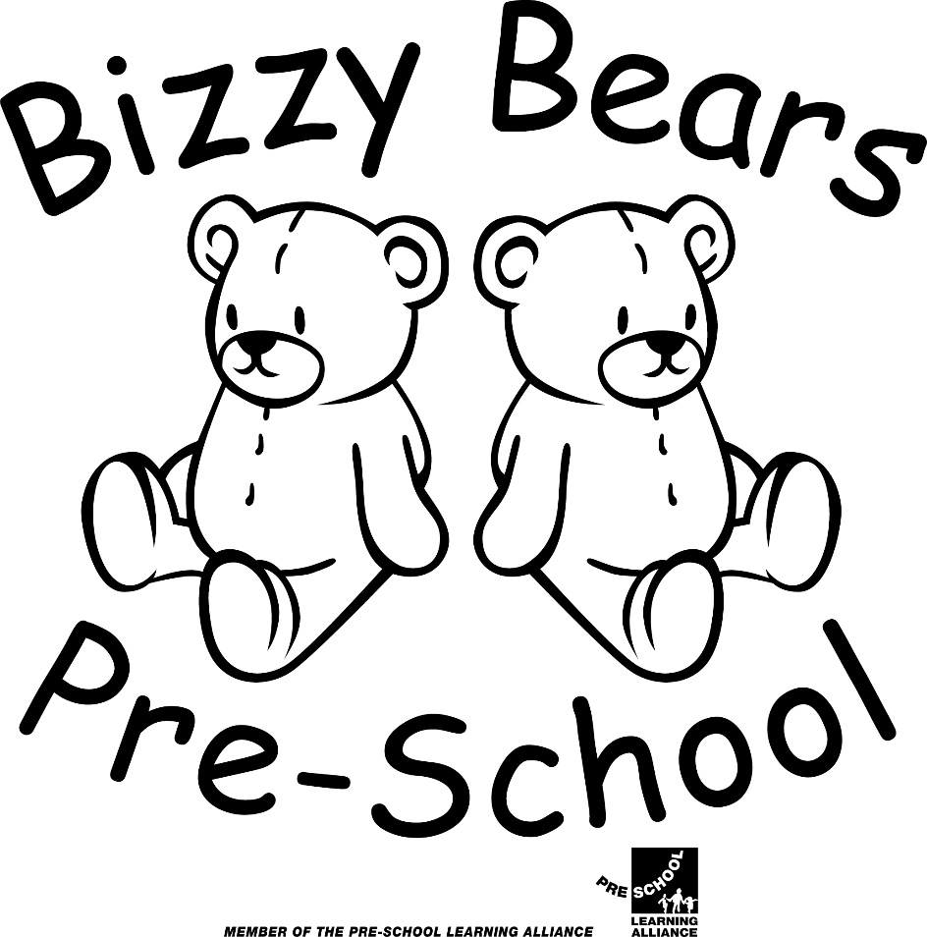

The Pavilion
Great Billing Playing Field
Great Billing
Northampton
NN3 9EF
01604 785123 www.bizzy-bears.com
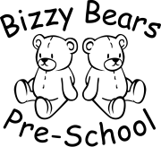
Welcome

Bizzy Bears runs from the Bernard Weston Pavilion in Gt Billing village which is owned by the Billing Parish.
We welcome all children within our local community between the ages of 2 years to rising 5’s.

We are registered with Ofsted (Office for Standards in Education) and the Early Years Childcare service in Northamptonshire.

Ofsted registration No EY382010

We are also members of the Early years alliance, a leading charity specialising in the early years. They provide advice, support, insurance and access to childcare and training.

Registration No 56810

Bizzy Bears Pre-School is owned by Corinna Evans.
Corinna owns two other Early years settings; Red Robins Nannery and Puddle ducks Preschool.

Our sessions
Monday – Friday
Morning: 9.00am-12.00pm
Lunch club: 12.00pm-12.30pm
Afternoon: 12.30pm-3.30pm
Full day: 9.00am-3.30pm

Term time only
We are closed on bank holidays

Our Ethos

Explore, Play and be Creative

We aim to provide a welcoming environment where children are encouraged to explore, play and be creative.

At Bizzy Bears Pre-school play takes place indoors and outdoors, and it is in these different environments that children explore and discover their immediate world. This enables them to practice new ideas and skills, build friendships, take risks, show imagination, creativity and solve problems on their own or with others.

Our highly skilled staff use their expertise to observe play and join in when invited, watching and listening before intervening. They value play, and provide safe but challenging environments that support and extend learning and development for every child.

To enable children to be confident to explore and grow, they need to feel secure and know that their voice matters. We begin to develop these relationships with families based on their needs. We work together to settle each child at their own pace.

Every child in our care will have been encouraged to develop confidence, independence and be ready for their next chapter in life.

We developed this Ethos with feedback from the children, parents and staff at Bizzy Bears.(October 2019)

Fees
Our fees are:
£20.00 per session 9.00am-12.00am or 12.30pm-3.30pm
£4.00 for lunch club (12.00am-12.30pm. Children will need to bring their own packed lunch)
£44.00 full day 9.00am-3.30pm
Payments are requested by internet banking transfer. All payments must be made in advance or have been received by your child’s first session of the week in accordance with our fee charging policy.
Please provide your bank or building society with the following information to make a direct payment:
Account name Bizzy Bears Pre school
Account number 00204004
Sort code 30-96-09
Payment amount (weekly, monthly or half termly as shown on the invoice above)
Your reference: Please use your child’s first initial and surname.
We also accept childcare vouchers.

We require a deposit when fee paying children are offered a place at Bizzy Bears. A deposit of £20.00 is payable this will be refunded when your child leaves Pre-school (non refundable if the child leaves within first 6 months to cover costs)
Fees continue to be payable in full if a child is absent due to sickness or holidays taken in term time.

Non Payment of Pre school fees
If Pre-School fees are not paid on your child’s first session of the week a verbal reminder will be given.
If payment is not received after the verbal reminder (on the child’s next session) you will be informed in writing that fees must be paid to keep your child’s place at Bizzy Bears.
If payment is not received on your child’s next session following the written reminder, your child’s place will be suspended until all outstanding fees are paid. (Sessions claimed under the free nursery entitlement will not be suspended).If no payment is recieved legal steps will then be taken to recover any outstanding fees.

Snack charge
We ask for a £1.00 voluntary contribution per session to cover snack/resources costs

Late collection charge
All children must be collected on time when the session ends, we do understand that emergencies do happen and this may make you late to collect your child. We would politely request a telephone call explaining the situation.
Any child not collected at the end of the session without notification and agreement with staff will incur an additional charge. This is £5.00 per 5 minutes, these charges will be put into place 5 minutes after the session ends. This is to cover the cost of 2 members of staff staying behind to wait with the child.
We will follow our procedures in our Non collection of children policy if necessary.

Early Education Funding
All children age 3 in Northamptonshire are eligible for a free early education place. Eligibility is based on the birth date of your child.

A child born between: | Will be eligible for a free place from:
1st April to 31st August (inclusive) | Autumn funding period following their 3rd birthday.
1st September to 31st December (inclusive) | Spring funding period following their 3rd birthday
1st January to 31st March | Summer funding period following their 3rd birthday

The grant entitles your child up to 15 hours of nursery education per week(excluding lunch club) for 38 weeks of the year, this is broken down into 3 terms:

Autumn term September - December
Spring term January - March
Summer term April – July

Parents/carers may choose for their child:
- To take up less than the minimum entitlement
- To receive their free place by attending more than one provider within a week
- To take additional services beyond the free entitlement( additional nursery education or lunch club) in which case Bizzy Bears will make a charge in line with their fee structure.

Parents/Carers will be informed by letter when their child is eligible for the free entitlement. All parents/carers must complete a Parent/carer contract form at the beginning of each calendar block and provide their child’s birth certificate and a current utility bill less than 3 months old, to qualify for the free entitlement.

30 hour Funded Childcare
You will be eligible if you earn more than the equivalent of 16 hours at the national living wage per week and you earn less than £100,000 per year. You can find out more information and see if you are eligible at www.gov.uk/30-hours-free-childcare
Eligible children will be entitled up to 30 hrs, 5 full days 9am-3.30pm not including lunch club 12.00pm-12.30pm ( children will need to bring a packed lunch) there is £4.000 charge. Parents do not have to take up the full entitlement. Childcare hours can be split between 2 providers.

Tax free childcare
Parents can find out more information about tax free childcare at www.gov.uk/tax-free-childcare
Bizzy Bears is a member of this scheme and is able to receive payments.

Snack cost
We ask for a voluntary £1.00 contribution per session to cover snack/resources costs
EYPP(Early Years Pupil Preminum)
Children who claim the 3 and 4 year old entitlement who meet the criteria could be eligible for the EYPP. The EYPP is additional funding to improve the outcomes for children. This funding is paid directly to your childcare provider. More information can be found at www.northamptonshire.gov.uk/EYPP Bizzy Bears will also provide you with written information as part of the 3 and 4 year old free entitlement process.

Two Year Old funding Early Learning
If you are a parent/carer of a 2 year old and receive certain benefits you could be entitled to 15 hours/six sessions of early learning (not including lunch club) a maximum of 570 hours per year(depending on spaces). To find out if you are eligible please go to www.northamptonshire.gov.uk/councilservices/children-families-education/early-years/Pages/childcare-funding.aspx If you are eligible you will be given a reference number which you will need to give to us to apply for the funding.

If for any reason you do not wish to keep your child’s place at Bizzy Bears at least one month/4 weeks notice in writing must be given

Preschool Team

Our experienced staff team all hold appropriate qualifications in Early years.
All staff are required to obtain a enhanced criminal records disclosure to check their suitability to work with children (DBS)
We offer placements for work experience students and childcare students to gain valuable experience in a childcare setting. They are supervised by Preschool staff at all times and do not have unsupervised contact with the children.

The following ratios of adults to children are in place :

Aged 2 - 3 years - 1 adult : 4 children
Aged 3 - 5 years - 1 adult : 8 children

Preschool Policies
We have a comprehensive set of policies and procedures that Bizzy Bears follows.
A copy of all our policies and procedures can be found in the policy book in the changing room at Bizzy Bears, on our website and on Tapestry in the documents section. We can also email parents a copy if requested.

Settling In

We aim to make Bears Pre-School a welcome place for you and your child. To help with the transition from home to Preschool we:
- Arrange a visit to the Preschool to enable families to have a tour of the building and facilities and to answer any questions that you may have

- We offer a minimum of 3 play sessions before a child starts at Bizzy Bears to enable you and your child to stay and play and meet the children and staff.

- We allocate a key Person from the Bizzy Bears team to each child and their family to help them become familiar with the setting, to ensure your child’s individual needs are met and to share information on a daily basis

- We believe each child is individual and we work with parents/carer’s to provide a flexible admissions procedure

- To ease the transition from home to Pre school we offer home visits to all our new families. Your child’s key person will come and visit you and your child in their own home prior to starting at Bizzy Bears at a time convenient to you. They will bring with them photographs of the activities we offer at Bizzy Bears and it will be an opportunity for you and your child to discuss their transition and ask any questions you may have.

- We operate an open door policy and welcome parents/ carer’s into our setting to share their interests and skills with us

When coming to Bizzy Bears your child will need:
- A named bag containing a change of clothes
- Indoor shoes that they can change into(no laces please!)
- Nappies, nappy cream and wipes if needed
- A waterproof suit and wellington boots for outdoor play/sun cream and sun hat

Pre-School uniform
We have a range of Preschool clothing available to purchase from Bizzy Bears
Age 2-3, 3-4 and 5-6

- T-Shirts £7.50
- Preschool polo top £8.50
- Sweatshirts £10.00
- Drawstrings bag displaying the Pre school logo are £6.00

Curriculum

Young children are experiencing and learning in the here and now. It is in this moment of curiosity that we can make a difference.
As skillful Preschool Practitioners we have set up an environment where the children can select what they want to do in each area from a wide range of resources. When we have identified areas of development for your child’s future focus then this learning will be put into the environment for your child to access.

Our curriculum intent: At Bizzy Bears Pre-school play takes place indoors and outdoors, and it is in these different environments that children explore and discover their immediate world. This enables them to practice new ideas and skills, build friendships, take risks, show imagination, creativity and solve problems on their own or with others.

We follow the Birth to five framework for every child from birth through to the end of reception year at school. All areas of learning and development are important and inter-connected.

There are three Prime areas which are fundamental to support development in all other areas.

Personal, Social and Emotional Development
Personal, social and emotional development involves helping children to develop a positive sense of themselves, and others; to form positive relationships and develop respect for others; to develop social skills and learn how to manage their feelings; to understand appropriate behaviour in groups; and to have confidence in their own abilities.

Communication and Language
Communication and language development involves giving children opportunities to experience a rich language environment; to develop their confidence and skills in expressing themselves; and to speak and listen in a range of situations.

Physical Development
Physical development involves providing opportunities for young children to be active and interactive; and to develop their co-ordination, control, and movement. Children must also be helped to understand the importance of physical activity, and to make healthy choices in relation to food.

There are four specific areas which include essential skills and knowledge. They grow out of the Prime areas, and provide important contexts for learning.

Literacy
Literacy development involves encouraging children to link sounds and letters and to begin to read and write. Children must be given access to a wide range of reading materials (books, poems, and other written materials) to ignite their interest.

Mathematics
Mathematics involves providing children with opportunities to develop and improve their skills in counting, understanding and using numbers, calculating simple addition and subtraction problems; and to describe shapes, spaces, and measures.

Understanding of the World
Understanding the world involves guiding children to make sense of their physical world and their community through opportunities to explore, observe and find out about people, places, technology and the environment.

Expressive arts and design
Expressive arts and design involves enabling children to explore and play with a wide range of media and materials, as well as providing opportunities and encouragement for sharing their thoughts, ideas and feelings through a variety of activities in art, music, movement, dance, role-play, and design and technology.

Two year old progress check
When a child is aged 2 years practitioners must review their progress and provide parents and/or carer’s with a short written summary of their child’s development in the three prime areas. This will be usually be undertaken within the first 2 months of them starting at Bizzy Bears Preschool. The progress check will identify the child’s strengths and any areas where the child’s progress is less than expected. We encourage Parents/carer’s to share this information with their child’s health visitor who will also carry out a 2 year health check.

On Line Learning Journal-Tapestry
We use Tapestry an online learning journal to build a very special record of a child’s experiences, development and learning journey through their early years at Bizzy Bears. Using photos, videos and observations of ‘wow moments’ these are recorded by the child’s key person.
All information held in the platform is stored securely. Parents/carer’s will need to give us permission to set up a learning journal for their child which can only be seen by the adults that they authorise. Parents or carers are able to view their child’s progress, the activities provided for them, and how much fun they’re having, whilst also uploading their own comments and media from home using an app or from the website. You will receive immediate notifications when a new observation/memo is added.
When your child moves on to school we make your child’s learning journal available to you to download and keep as a memory of their time at Bizzy Bears.

https://tapestryjournal.com
Additional

Special Educational needs and disability(SEND)
Our Pre-school aims to provide a welcoming and caring environment in which all children are supported to reach their full potential.
We work together with the child’s parent/carer and other relevant agencies to assess the suitability of our environment, staffing arrangements, equipment and activities to ensure we can adapt for the needs of the child. Parents/carers will be able to share with the setting the in-depth knowledge and understanding they have of their child as part of the admissions procedure.
All staff has experience and knowledge in child development and early identification of SEND. Our Pre-School has regards to the DFES Special Educational Needs code of practice. Our Special Educational Needs Coordinator (SENCO) is the Manager

English as an Additional Language

We ensure that children and families whose first language is not English have full access to the curriculum and are supported in their learning.
We gather information from families on admission using the EAL toolkit and key words. We use and display key words in the families home language, use visual pictures and adjust activities and experiences to ensure equal opportunities for all children, we support children to develop language using small group activitities. We share information with families in a variety of ways (translate and dual language documents) We value the contribution their language and culture offer our Pre school.
Safeguarding

Our aim is to protect the children in our care against abuse of any form. Our intent is to demonstrate a commitment to safeguarding young children. All staff attend regular safeguarding training which is ongoing. Our named Child protection coordinator is the Manager who is supported by Catherine Real (Deputy manager) We follow the local safeguarding guidelines. Information for parents Home - Northamptonshire Safeguarding Children Board (northamptonshirescb.org.uk)

Complaints Procedure

If parents have any concerns relating to any aspect of Bizzy Bears Pre-School please arrange to speak to the Pre-School Manager/ Deputy where the matter will receive urgent attention. In the unlikely event that this meeting does not successfully resolve the matter we would be happy to advise you of the relevant steps to take as set out in our Complaints policy which can be found in our policy brochure at Preschool,on our Pre school website and on Tapestry in the documents section.

If parents have any concerns about any aspect of our provision they may contact Ofsted directly.
0300 123 1231
Home to Pre school Communication
We share information about your child on a daily basis through:
- Verbally
- Today we board displayed outside
- Telephone conversations
- Tapestry
- Email info@bizzy-bears.com
- Monthly newsletter
- Termly progress summaries
- Parent consulations
- School leavers transition documents
- Facebook and Instagram and our website www.bizzy-bears.com

Health Matters
Accidents at Home
If a child comes to Pre-School with an existing injury and we are notified by the parent, we ask the parent to complete the accident at home book to ensure we have relevant information and are aware of any possible side effects.(these are recorded on our white board to notify all staff if observation of the child is needed) .

Sickness
Parents are asked to keep their child at home if they are unwell and to inform us as to the nature of the illness so that we can provide relevant information to other parents if the nature of the illness is infectious.
If you feel your child is unwell enough to require Calpol/Nurofen or any other Paracetamol product before coming to Pre school, we would ask that you keep them at home
Parents are asked to keep a child away from Pre-school, who has been suffering from vomiting or diarrhoea until at least 48 hrs has elapsed since the last incident.

Additional
Emergency Closure Procedure
Bizzy Bears Pre-school is required to draw up an emergency procedure which is to be followed in the event of an incident within Pre-school hours where we have to vacate the building and are unable to return.
The staff and children will walk the short distance to:
St Andrews C of E school, Ecton Brook road, Ecton Brook 01604 406486
where parents /carers will be contacted and asked to collect their children.

Internet use
Staff/Parents/Carer’s and Visitors to our setting are asked not to access their mobile phones whilst inside the Pre school building. Staff/visitors to our setting are asked to place them in our secure office with their personal belongings during the session
Lunch session
Lunch time is a sociable occasion where the children can sit with their friends and enjoy eating their packed lunch. You can choose to add a lunch club session onto any morning or afternoon session 12.00am-12.30pm. The fee for this session is £4.00 and children will need to bring in their own packed lunch.

Ideas for a healthy packed lunch
- A portion of savoury food either a sandwich, wrap, roll or a small pot of pasta or savoury crackers
- A portion of vegetables
- A portion of fruit fresh
- Dairy( yogurt, rice pudding) cheese
- A drink of water or diluted juice in a named bottle

- Please keep servings small.(2 small sandwiches made with one piece of bread, half a pitta bread, a child size bagel)
- We would ask that grapes, strawberries, cucumber and cherry tomatoes, cocktail sausages be cut in half lengthways as these can be choking hazards.
- Please do not include sweet treats in your child’s lunch box ie chocolate bars, sweets, fizzy drinks. Sweet alternatives can be malt bread, banana bread, sugar free fruit jelly or a low sugar yogurt
- Please try and limit the amount of processed foods in your child’s lunch box (cracker pots, fruit flakes, processed cheese, smoothies) as these can be high in salt and sugar
- Please can parents label all lunch boxes, drinks bottles and food containers with your child’s name
We encourage the children to eat savoury items first. Although it may look messy we put any uneaten food back in the lunch boxes/bags so Parents/carers can monitor what their child has eaten.

Keeping food fresh and safe
- Please provide a small spoon or fork if needed
- Children’s lunch boxes are stored in the changing rooms until lunch time, as the weather becomes warmer please provide cool boxes or blocks inside your child’s lunch box
- We are unable to heat food that children bring in from home.

We are a nut free Preschool, so please do not include any whole nuts or peanut butter in your child’s packed lunch or any shell fish due to allergies.

Contact Information

Bizzy Bears Pre-School

The Pavilion

Billing Playing Fields

Great Billing

Northampton

NN3 9EF
Website :www.bizzy-bears.com | E-Mail : info@bizzy-bears.com

During sessions :01604 785123

Outside Pre school hours for emergencies only :07895 337419

Useful contacts for Parents/Carers:

Northamptonshire County Council
Information on childcare/Free 2,3 and 4 year old entitlement places/school admissions/ 2year old eligibility checker for parents www.northamptonshire.gov.uk/councilservices/children-families-education/early-years/Pages/default.aspx

Information about tax free childcare and the 30 hour entitlement www.gov.uk/30-hours-free-childcare
www.childcarechoices.gov.uk

Applications, Regulatory and Contact (ARC) Team
Ofsted 0300 123 1231
Piccadilly Gate
Store Street
Manchester
M1 2WD
www.gov.uk/government/organisations/ofsted
If parents have any concerns about any aspect of our provision they may contact Ofsted using the contact details above

